**Project Report**

*1. Introduction*

During the Bootstrap course I took on a side project that included building a portfolio/resume website. Now I would like to take that design and use what I’ve learned in React to make it more efficient and user friendly.

*2. User Interface Design and Prototype*

Here are some screenshots of my current portfolio site and the URL is in the references below:

**Landing Page**

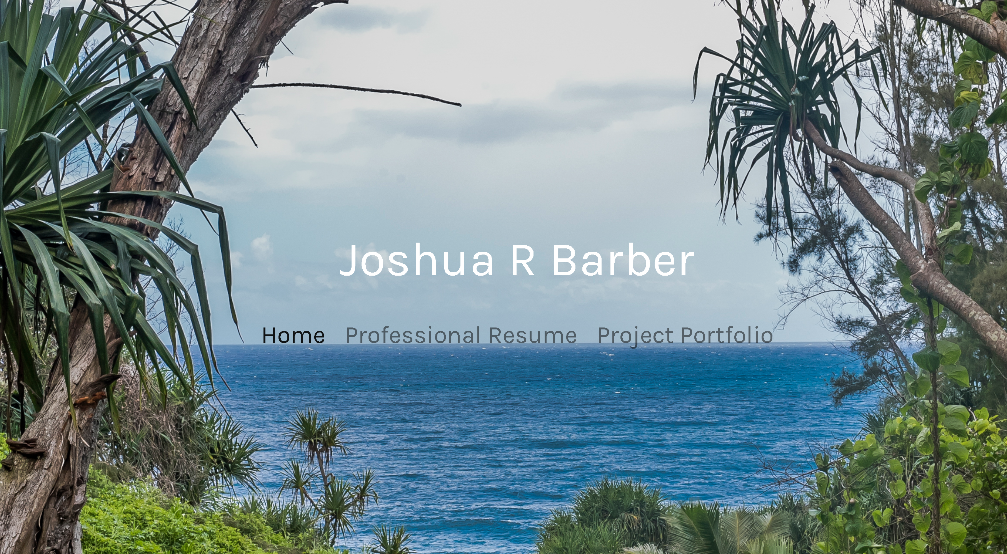

Resume Page

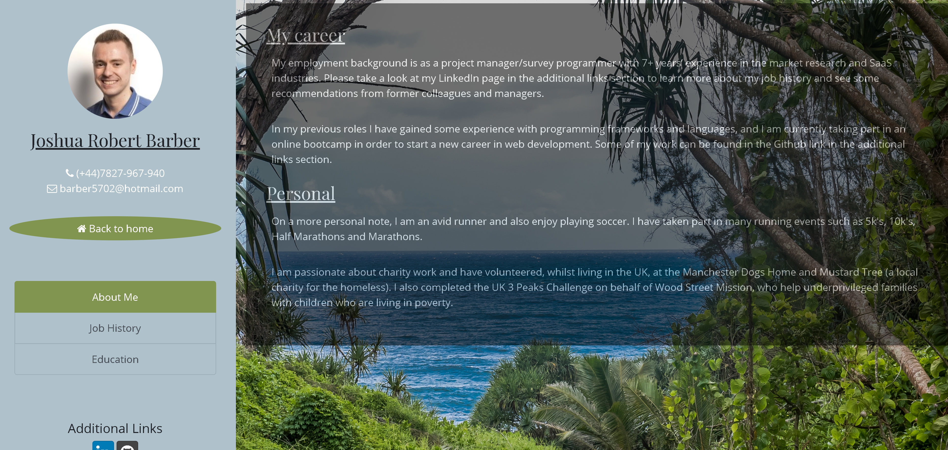

**List of Portfolio Projects**

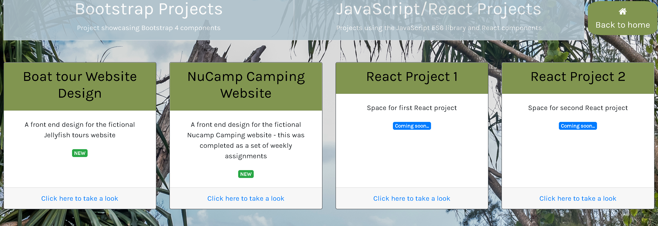

*3. Navigation Structure*

I’ll obviously want to restructure this so the layout is more consistent/user friendly, and also I will have the resume and list of projects all on a single page.

I will be using the walkthrough guide in the references as a starting point, which I will then build on in order to personalize the site to my own tastes.

*4. References*

<https://joshuarbarber.com/>

<https://codeburst.io/learn-react-js-build-a-portfolio-single-page-application-spa-ba001082a711>